**Project Design Phase-II**

**Technology Stack (Architecture & Stack)**

| Date | 17 October 2022 |
| --- | --- |
| Team ID | PNT2022TMID49326 |
| Project Name | Fertilizers Recommendation System  For Disease Prediction |
| Maximum Marks | 4 Marks |

**Technical Architecture:**

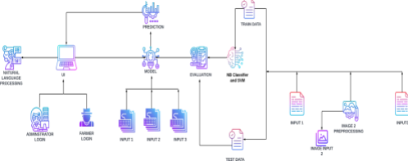**Table-1 : Components & Technologies**

| **S.N**  **o** | **Component** | **Description** | **Technology** |
| --- | --- | --- | --- |
| 1. | User Interface | How the user interacts with  the application .To depict  the  human-computer interaction  and communication. | HTML, CSS,JSP |
| 2. | Application Logic-1 | A page to upload images as input | Python |

| 3. | Application Logic-2 | To use the Machine  Learning model and  predicting the result | Python |
| --- | --- | --- | --- |
| 4. | Database | Structured data-images | MySql |
| 5. | Cloud Database | Database that typically runs on a cloud computing platform and  access to the database is provided as-a service | IBM Cloud  Databases for  MySQL |
| 6. | File Storage | To store data in a  Hierarchical structure | Local File system |
| 7. | Machine Learning  Model | Here, we use a Support  Vector Machine Algorithm  that is used widely in  Classification and  Regression problems. | Random Forest  ,XG Boost |

**Table-2: Application Characteristics:**

| **S. No** | **Characteristics** | **Description** | **Technology** |
| --- | --- | --- | --- |
| 1. | Open-Source  Frameworks | Flask micro web framework | Written in Python.  It is classified as a  micro frame work  because it does  not require  particular tools or  libraries. It has no  database  abstraction layer,  form validation, or  any other  components  where preexisting  third-party  libraries provide  common  functions. |

| 2. | Security Implementations | With all aspects of the job, including detecting malicious attacks , analyzing the network, endpoint protection and vulnerability assessment, Sign in encryption | IBM Cloud App ID  Services |
| --- | --- | --- | --- |

| 3. | Availability | Available for all data size | - |
| --- | --- | --- | --- |
| 4. | Performance | Can extend the storage  according to our needs | Python, Angular JS |